PYTHON ASSIGNMENT

1)

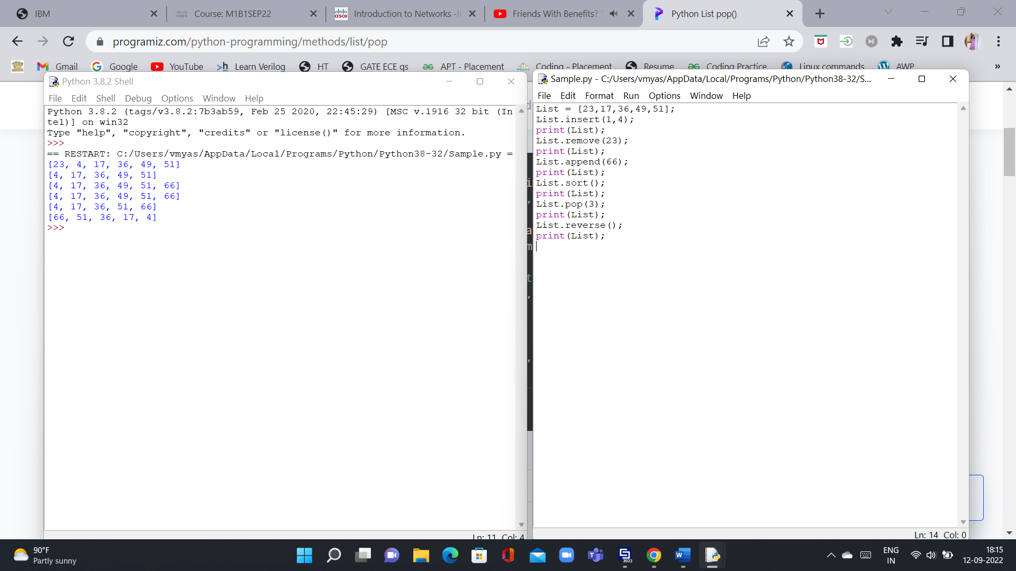

2)

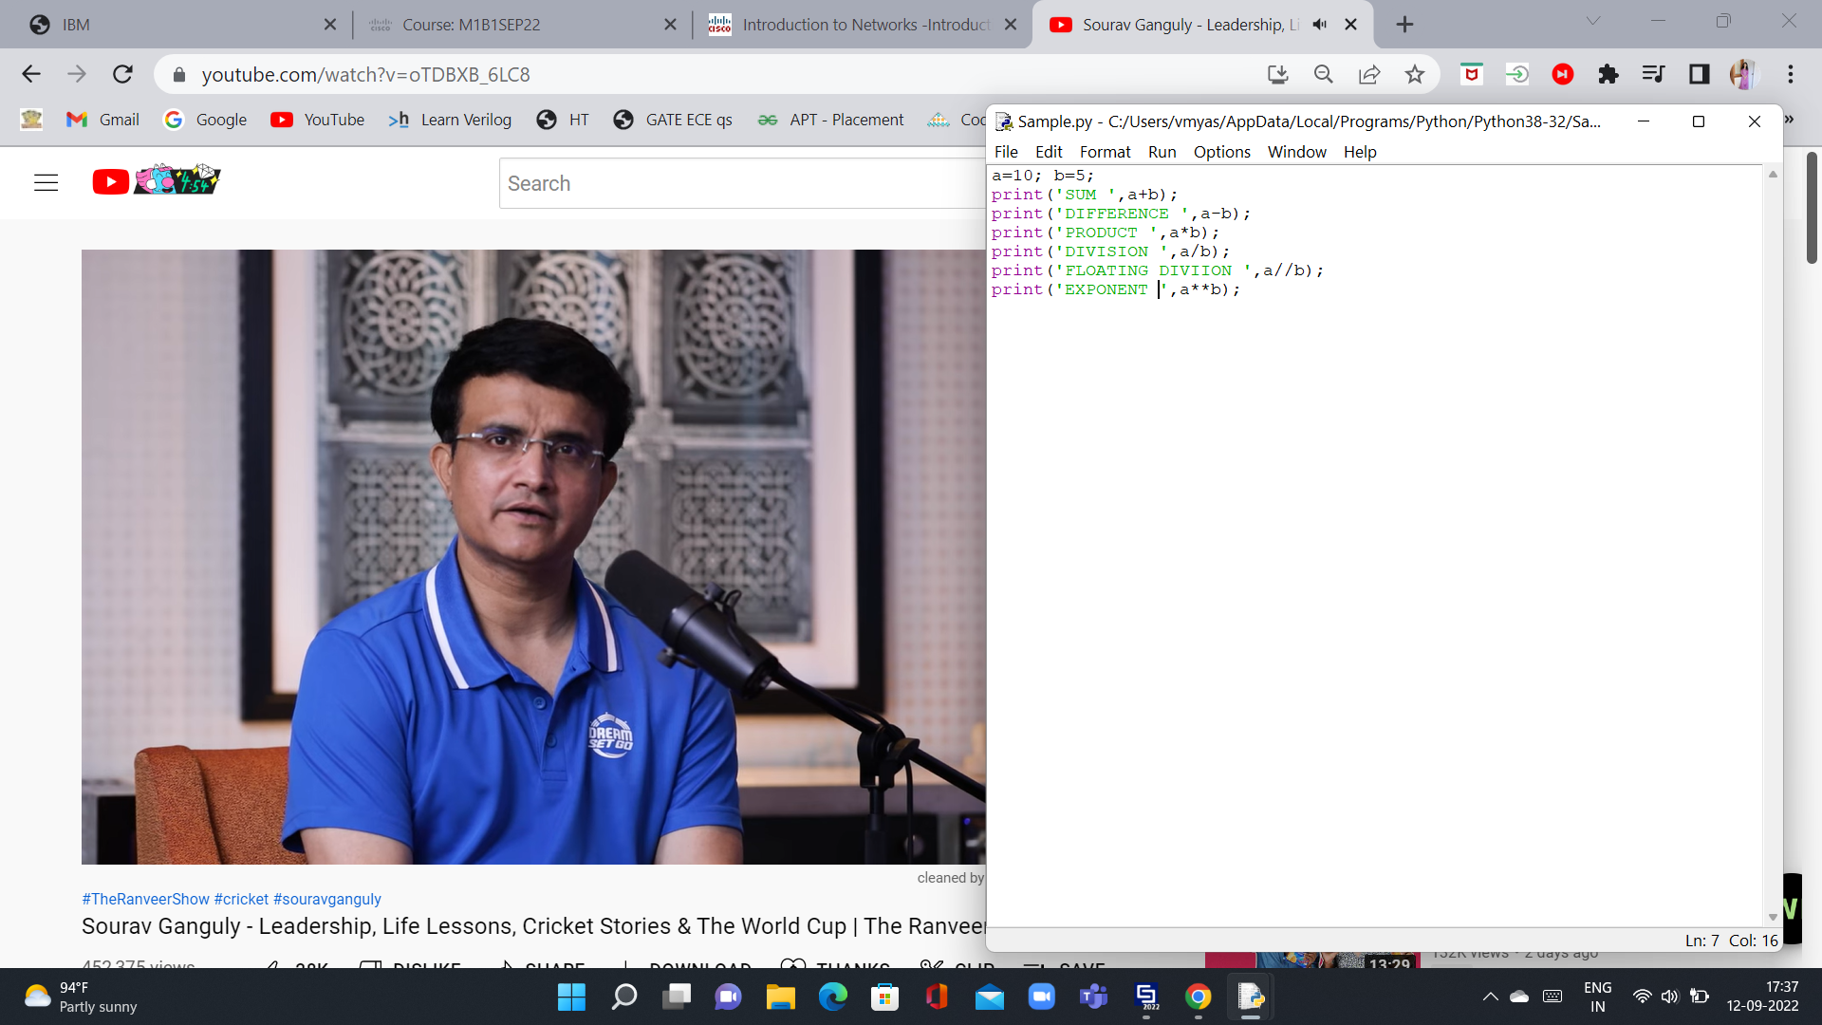

3)

4) Python is a popular language because it is easy to learn and read with simple English syntax. Its an open source interpreted scripting modular functional and object oriented language.

5) Python framework – Flask(microservices) , Django(fullstack) , Pyramid(fullstack) , Sanic(asynchronous)

6) WSGI – Web Server Gateway Interface